**PIZZA SALES**

***Problem Statements :***

1. **Total revenue : Sum of total price of all pizza orders**
2. **Average Order Value : Average amount spent per order**
3. **Total Pizzas sold**
4. **Total number of orders**
5. **Average pizzas per order**

***Charts Requirement :***

1. **Daily trends for total orders**
2. **Hourly trends for total orders**
3. **Percentage of sales by pizza category**
4. **Percentage of sales by pizza size**
5. **Total pizzas sold by pizza category**
6. **Top 5 best sellers by total pizzas sold**
7. **Bottom 5 worst sellers by total pizzas sold**

**SQL QUERIES**

**A. KPI’s**

**1. Total Revenue:**

*SELECT SUM(total_price) AS Total_Revenue FROM pizza_sales;*

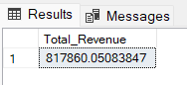

**2. Average Order Value :**

*SELECT (SUM(total_price) / COUNT(DISTINCT order_id)) AS Avg_order_Value FROM pizza_sales*

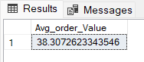

**3. Total Pizzas Sold :**

*SELECT SUM(quantity) AS Total_pizza_sold FROM pizza_sales*

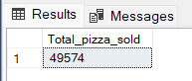

**4. Total Orders :**

*SELECT COUNT(DISTINCT order_id) AS Total_Orders FROM pizza_sales*

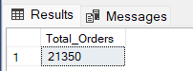

**5. Average Pizzas Per Order :**

*SELECT CAST(CAST(SUM(quantity) AS DECIMAL(10,2)) /*

*CAST(COUNT(DISTINCT order_id) AS DECIMAL(10,2)) AS DECIMAL(10,2))*

*AS Avg_Pizzas_per_order*

*FROM pizza_sales*

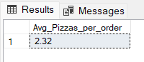

**B. Daily Trend for Total Orders***SELECT DATENAME(DW, order_date) AS order_day, COUNT(DISTINCT order_id) AS total_orders*

*FROM pizza_sales*

*GROUP BY DATENAME(DW, order_date)*

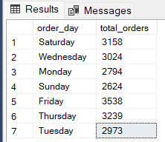

**C. Hourly Trend for Orders**

*SELECT DATEPART(HOUR, order_time) as order_hours, COUNT(DISTINCT order_id) as total_orders*

*from pizza_sales*

*group by DATEPART(HOUR, order_time)*

*order by DATEPART(HOUR, order_time)*

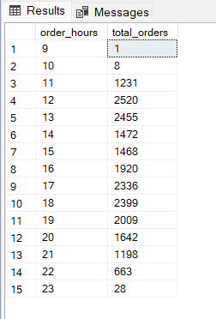

**D. Percentage of Sales by Pizza Category**

*SELECT pizza_category, CAST(SUM(total_price) AS DECIMAL(10,2)) as total_revenue,*

*CAST(SUM(total_price) * 100 / (SELECT SUM(total_price) from pizza_sales) AS DECIMAL(10,2)) AS PCT*

*FROM pizza_sales*

*GROUP BY pizza_category*

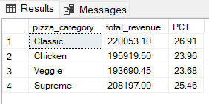

**E. Percentage of Sales by Pizza Size**

*SELECT pizza_size, CAST(SUM(total_price) AS DECIMAL(10,2)) as total_revenue,*

*CAST(SUM(total_price) * 100 / (SELECT SUM(total_price) from pizza_sales) AS DECIMAL(10,2)) AS PCT*

*FROM pizza_sales*

*GROUP BY pizza_size*

*ORDER BY pizza_size*

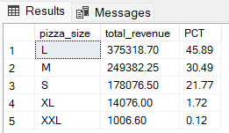

**F. Total Pizzas Sold by Pizza Category**

*SELECT pizza_category, SUM(quantity) as Total_Quantity_Sold*

*FROM pizza_sales*

*WHERE MONTH(order_date) = 2*

*GROUP BY pizza_category*

*ORDER BY Total_Quantity_Sold DESC*

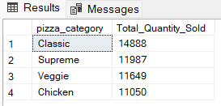

**G. Top 5 Best Sellers by Total Pizzas Sold**

*SELECT Top 5 pizza_name, SUM(quantity) AS Total_Pizza_Sold*

*FROM pizza_sales*

*GROUP BY pizza_name*

*ORDER BY Total_Pizza_Sold DESC*

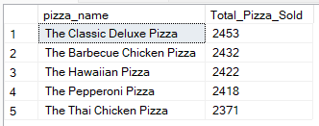

**H. Bottom 5 Worst Sellers by Total Pizzas Sold**

*SELECT TOP 5 pizza_name, SUM(quantity) AS Total_Pizza_Sold*

*FROM pizza_sales*

*GROUP BY pizza_name*

*ORDER BY Total_Pizza_Sold ASC*

